King Saud University

College of Computer and Information Sciences
Information Systems Department
Assignment No. 5 (from Chapter No 5)
Decision Support System (IS 466)

Student ID: Name:

Note:
According to what we have covered on class discussion, textbook, internet search and other references answer the following questions and submit via Learning Management System (Blackboard).
Please save your files as: IS466_Assignment 5_Student ID

Question No. 1. An Ontario company receives two units of a product at the beginning of each week. There is no cost of placing orders as production is done in-house. The weekly demand for the product has the following probability distribution:

Demand |  | Probability |  | Random Number
0 |  | .12 |  | __________
1 |  | .20 |  | __________
2 |  | .45 |  | __________
3 |  | .23 |  | __________
Simulate 10 weeks of the inventory system:
Week |  | Random Number |  | Beginning Inventory |  | Demand |  | Ending Inventory |  | Lost Sales
1 |  | 82 |  | ______ |  | ______ |  | ______ |  | ______
2 |  | 46 |  | ______ |  | ______ |  | ______ |  | ______
3 |  | 09 |  | ______ |  | ______ |  | ______ |  | ______
4 |  | 28 |  | ______ |  | ______ |  | ______ |  | ______
5 |  | 55 |  | ______ |  | ______ |  | ______ |  | ______
6 |  | 77 |  | ______ |  | ______ |  | ______ |  | ______
7 |  | 84 |  | ______ |  | ______ |  | ______ |  | ______
8 |  | 51 |  | ______ |  | ______ |  | ______ |  | ______
9 |  | 86 |  | ______ |  | ______ |  | ______ |  | ______
10 |  | 89 |  | ______ |  | ______ |  | ______ |  | ______

The cost of a lost sale is $5.00 and the cost of holding inventory is $0.04 per unit per week (based on average inventory). Assuming a 50-week year, find the total annual cost of this inventory policy. What recommendation would you make for reducing the total annual cost?

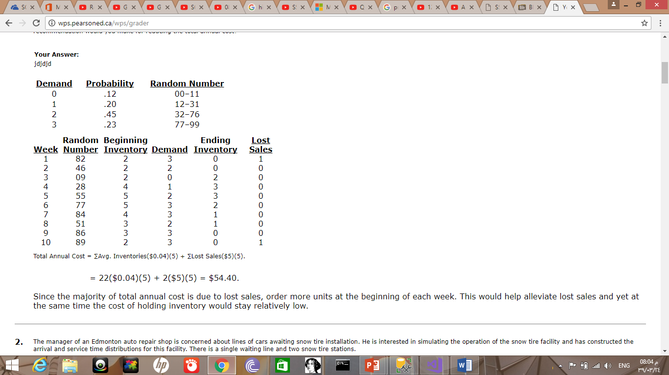
Question No. 2. The manager of an Edmonton auto repair shop is concerned about lines of cars awaiting snow tire installation. He is interested in simulating the operation of the snow tire facility and has constructed the arrival and service time distributions for this facility. There is a single waiting line and two snow tire stations. Simulate the first 10 customers of the day. Estimate the average time a car spends waiting for snow tire installation.
Interarrival Time (minutes) |  | Prob. |  | Service Time (minutes) |  | Prob.
10 |  | .08 |  | 15 |  | .05
11 |  | .18 |  | 16 |  | .10
12 |  | .30 |  | 17 |  | .15
13 |  | .20 |  | 18 |  | .45
14 |  | .19 |  | 19 |  | .25
15 |  | .05
Assume that the repair shop opens at 8:00 a.m. Use the following random numbers, reading horizontally and selecting random numbers as required:
For arrivals:
10 | 72 | 53 | 04 | 29 | 54 | 92 | 16 | 33 | 71

For service:
89 | 76 | 81 | 55 | 96 | 86 | 63 | 36 | 58 | 09

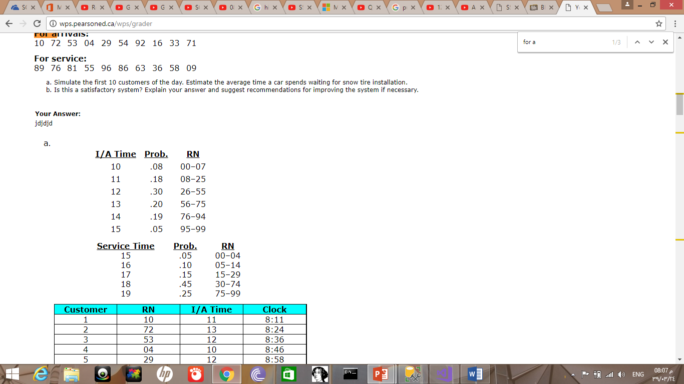
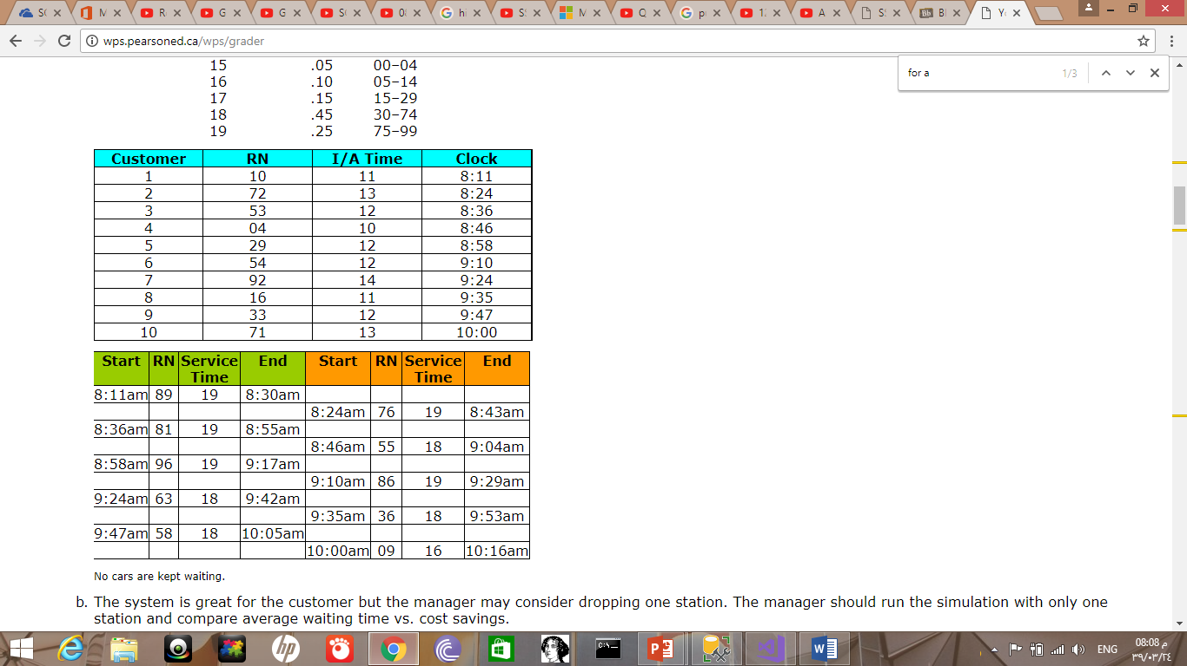
Question No. 3. Discuss some advantage and disadvantage in simulation?
